|  |  |  |
| --- | --- | --- |
| BINGHAMTON CITY SCHOOL DISTRICT  BINGHAMTON - SCHOOL |  |  |
|  |  |  |
| School Detail :- Binghamton City School District is the public school district for the city of Binghamton, New York. As of 2021 about 5,000 students in total were enrolled in the district.[2] In the 2017 and 2018 school years, 60% of students were minorities, and slightly more than half were eligible for free or reduced lunch.  Binghamton City School District is the public school district for the city of Binghamton, New York. As of 2021 about 5,000 students in total were enrolled in the district.[2] In the 2017 and 2018 school years, 60% of students were minorities, and slightly more than half were eligible for free or reduced lunch. |  |  |
|  |

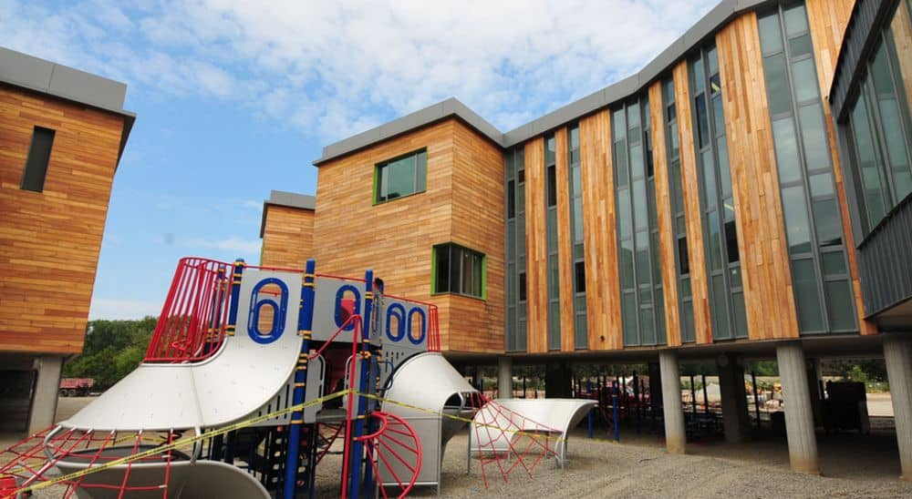

MINIMUM CAPACITY :-

The Minumum intake capacity

of students is between 280-310

children

LIBRARY :-

The Libarary is Available.

CANTEEN:-

The Canteen Facility is Available.

BOARDING :-

No availablility of boarding.

SPORTS :-

There are different categories

sports available.

Girls Volleyball

Boys Volleyball

Football